
K&M Tire
Warehouse Administration Manager SOP
12/4/2025

Table of Contents
1. K&M Tire 1
2. Office Manual Introduction 4
3. Overview 5
3.1 Conventions 5
3.2 Cautions & Warnings 5
4. Organizational Chart & Contacts 6
4.1 Organizational Chart 6
4.2 3CX – Phone System 6
4.3 Location Contact List 6
4.4 Organizational Information / Links 6
5. Vendor Shortage Billing 7
5.1 Vendor Shortage Steps 7
6. New Return Credits 13
6.1 System Receiving- Non-WISE locations 23
6.2 Return Goods Authorization 31
7. Building A New Expected Receipt- WISE Locations 32
8. Importing a Receipt from the Vendor Websites- Wise Locations 34
8.1 Closing A Receipt / Receiving in a WISE Location 35
8.2 Inventory Variance 39
9. Pulling packing lists from Vendor Websites 40
9.1 Goodyear 42
9.2 Falken 44
9.3 Hankook 45
Appendix A: Revision History Tracking 1

K&M Tire
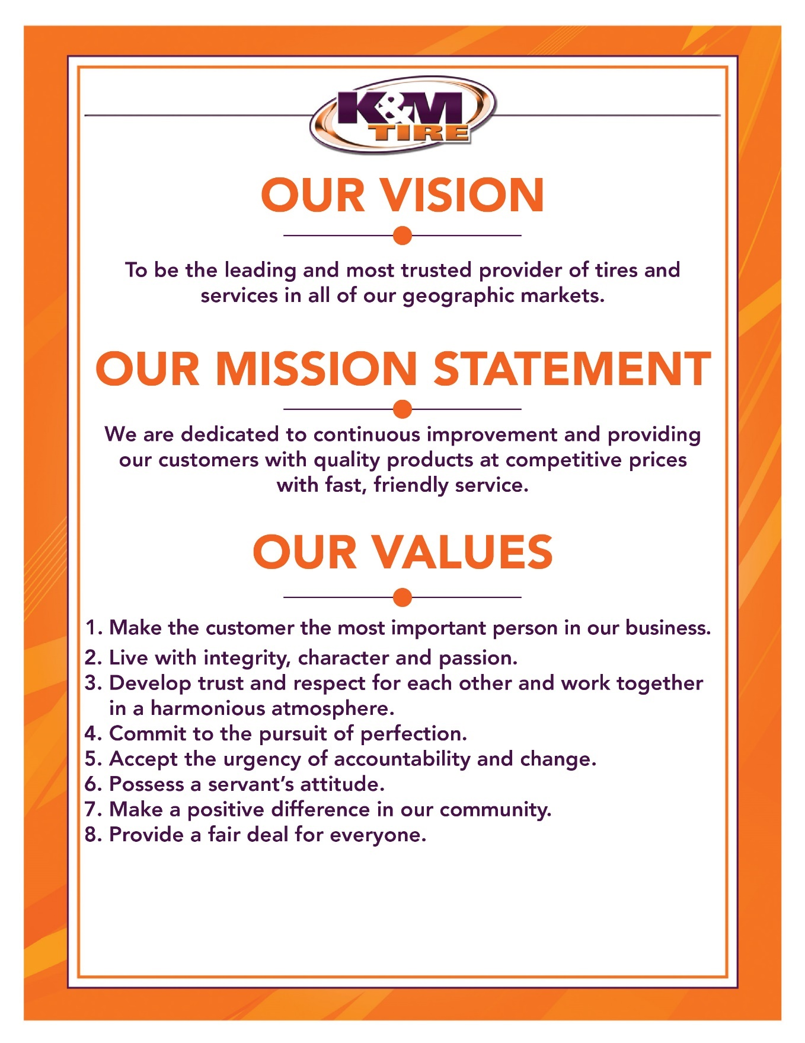

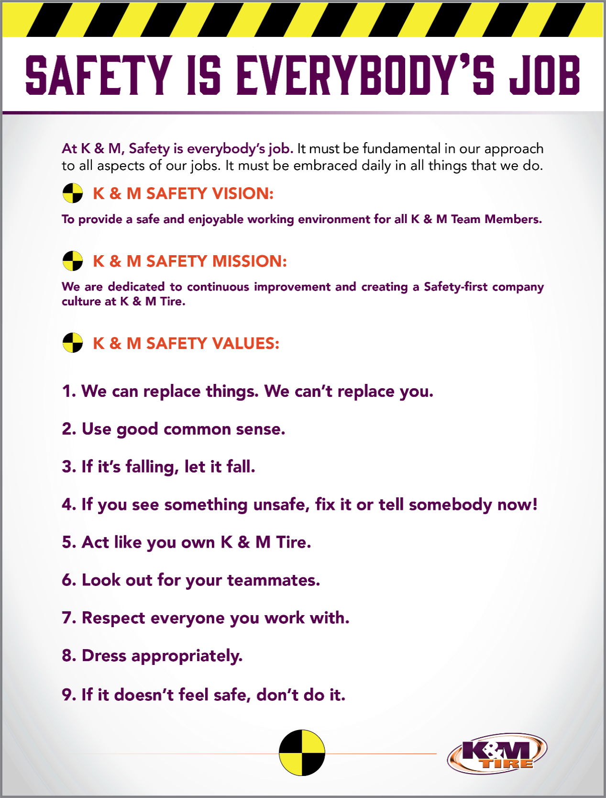

K&M Tire US Footprint
Click on the link below to see the footprint map
http://kmtire.com/km-cgi/distmap

Office Manual Introduction
This manual is intended to aid in the training of the K&M Tire Warehouse Manager by providing step by step details of the processes.

F:\SOP\Operations\Warehouse Administration Manager-WAM\Warehouse SOP Binder 12.4.2025.docx

Overview

Conventions
This document provides screen prints and corresponding narrative to describe how to use the Maddenco, WISE and K&M Intranet, known as “company systems”
When an action is required on the part of the reader, it is indicated by a line beginning with the word “Action:” For example:
Action: Click on OK.
Fields or buttons to be acted upon are indicated in bold italics in the Action statement; links to be acted upon are indicated as links in underlined blue text in the Action statement.
Note: The term ‘user’ is used throughout this document to refer to a person who requires and/or has acquired access to the company systems.

Cautions & Warnings
This manual does not supersede any safety or company policy.

Organizational Chart & Contacts

Organizational Chart
https://ess.paylocity.com/people/directory?openOrgChart=true&__viewedCompanyId=93259

3CX – Phone System
Add Link Here

Location Contact List
F:\Administrative Assistants\Public\Location Cheat Sheet.xlsx

Organizational Information / Links
Add Link Here

Vendor Shortage Billing

When product is delivered and received at our warehouses, any discrepancies of what we received verses what is on the packing list need to be corrected by creating an invoice to the vendor.
Overview: Bill Vendors for any shortages or overages in Order Entry out of the location that received the product. Email a copy of the invoice, packing list marked short/over and the signed (by both K&M Tire and driver) and dated bill of lading marked short/over to Accounts Payable/Accounts Receivable (this depends on the amount of the over/short being billed to the vendor) once it has been completed.
- If short bill over $100 – Accounts Payable
- If short bill under $100 – Accounts Receivable
- If over credit over $500 – Accounts Payable
- If over credit under $500 – Accounts Receivable
We will need all the appropriate documentation to get the credit back from the vendor.
(Note: This is important to be done no later than 48 hours with the proper documentation. Some vendors will not honor the shortage claim and we will have to write off the expense.)

Vendor Shortage Steps
- 1 Tire Dealer System - enter

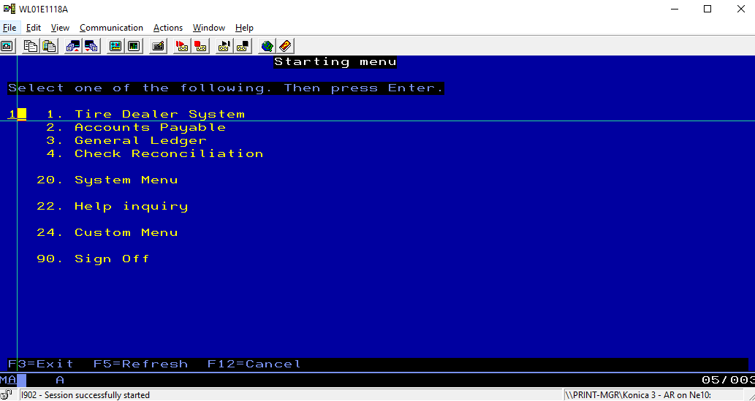

- 7 Warehouse Order Entry- enter

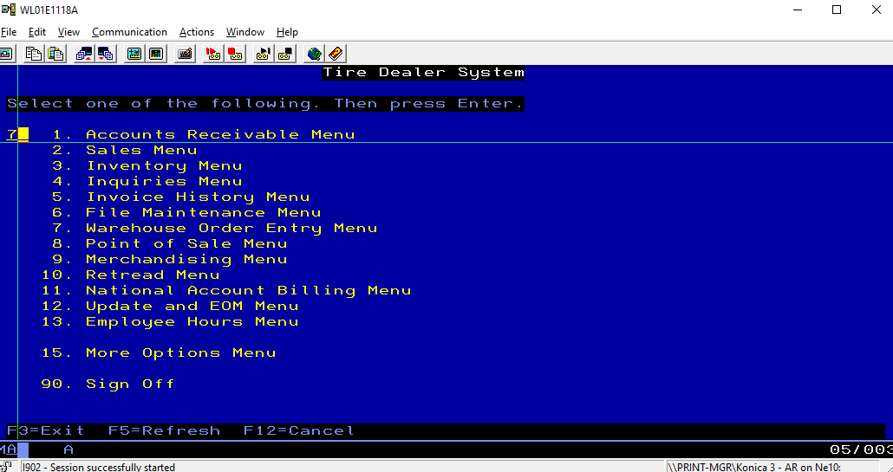

- 1 Order Entry- enter

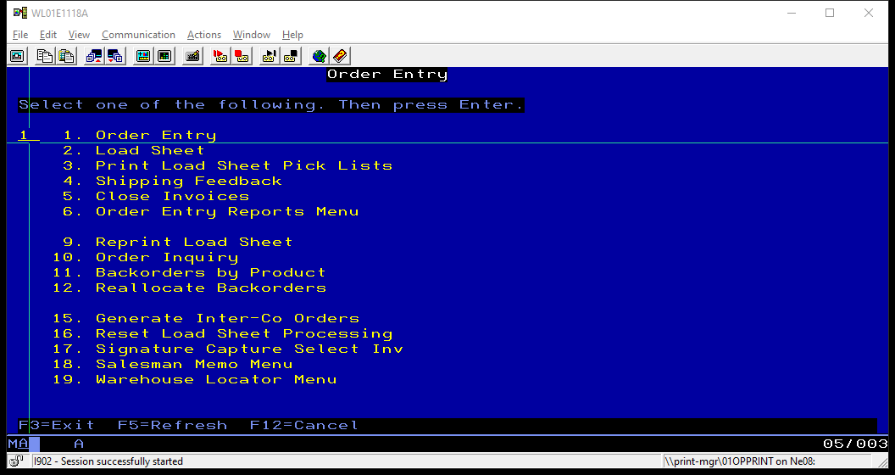

- Enter Location number-tab/enter

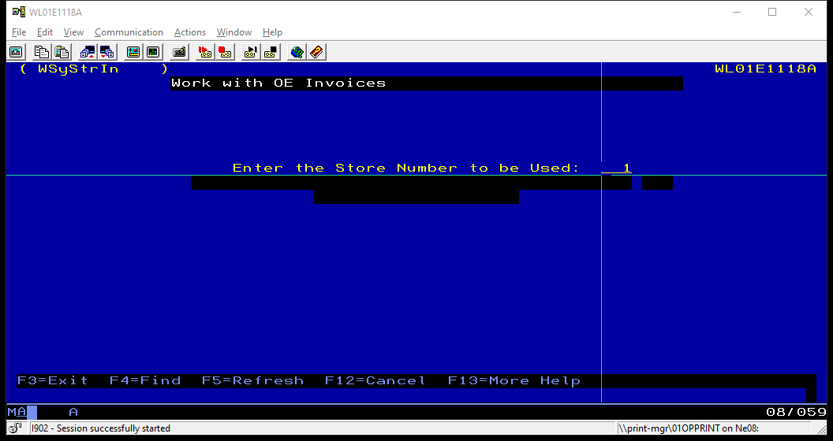

- Type the appropriate vendor’s account number on the customer line (see attached vendor list ..\..\..\..\..\Purchasing & Pricing\Shared\Forms & List & Charts\Vendor Shipping Numbers 2-16-2023.xlsx - enter

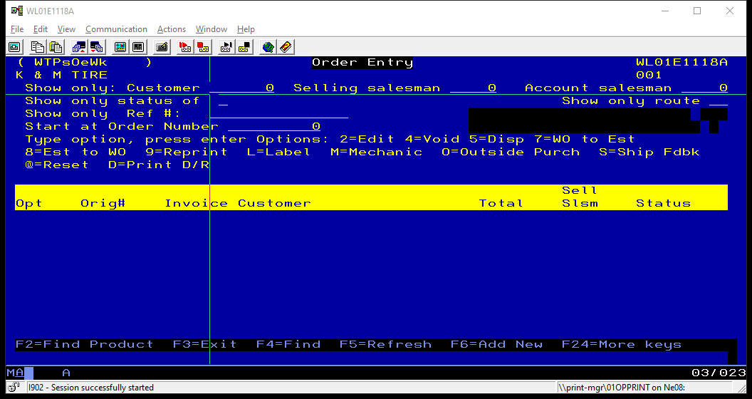

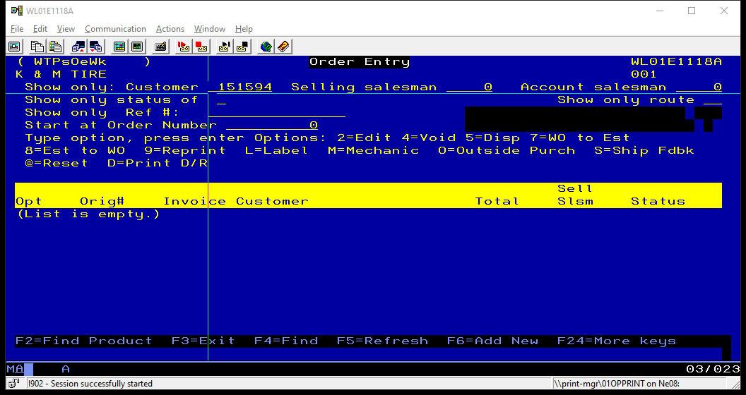

- Enter salesperson 010 – enter

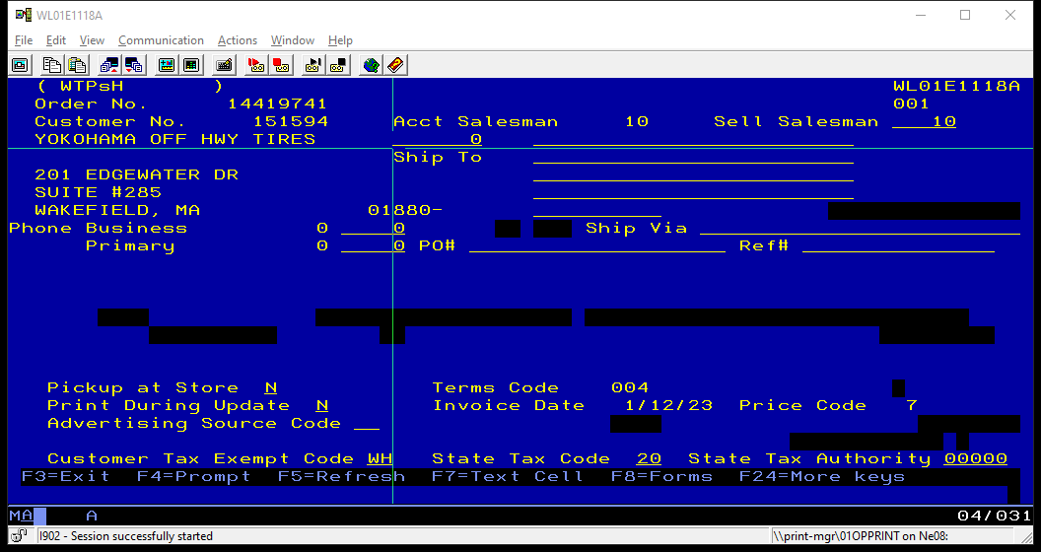

- Type the product code – enter

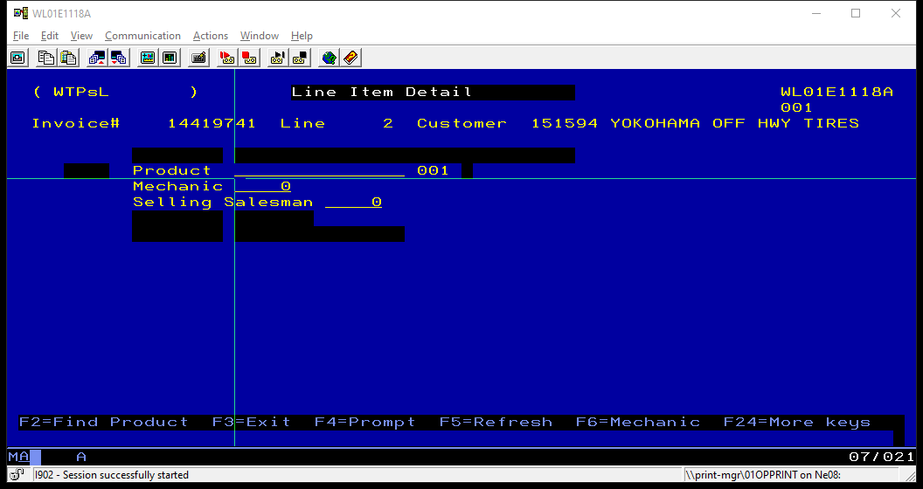

- Type the quantity shorted – enter

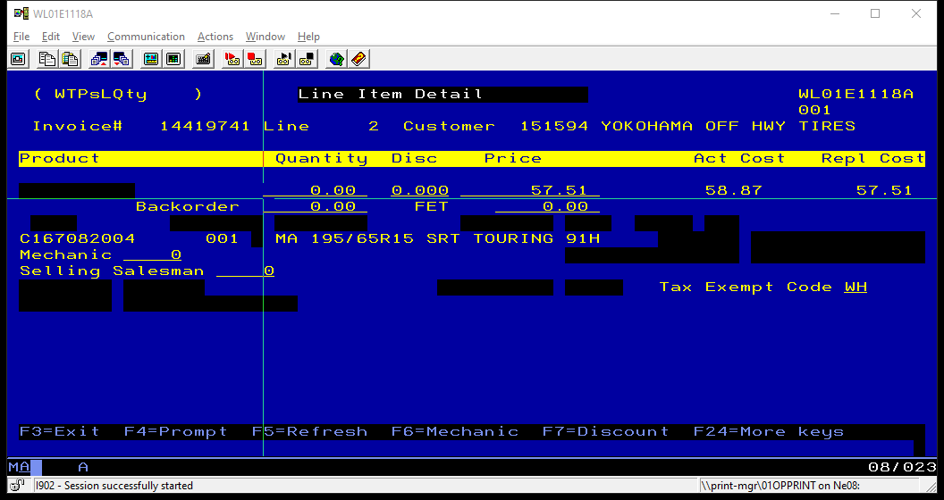

- (If it’s an overage, the quantity needs entered as a credit by typing in the quantity and pressing the minus sign)
- Make sure the product was not automatically backordered (if so, edit the line and remove the quantity from the backordered column)

- Start at step 8 to add another product.

- F3 once complete

- Close the invoice – locate the work order and type S on the work order line – enter

- F3 enter – end order
- Is invoice to be closed? Answer Y
- Payment method - enter

New Return Credits

A New Return is any product delivered to a customer that no longer needs the product and is returning it. Any tires must be new and never mounted. Warehouses should check this before sending in the return.
Overview: Managing new returns correctly, is a critical component of customer service, inventory accuracy and profitability. We must be certain to select the correct customer, the right product and determine the original purchase price so that we issue an accurate credit amount.
(Note: This is important because we want to make sure that we are not over crediting the customer as well as not under crediting them. Also, we want to make sure that the right quantity is being credited to so that our inventory matches and does not create a variance.)
The process starts with an estimate being returned by a driver, quantity and product code is verified at the warehouse level to match what’s on the estimate, and then the estimate is sent to the support group. Also, be on the lookout for new return credits that have a message stating “5% or 10% restocking fee.” See example below…

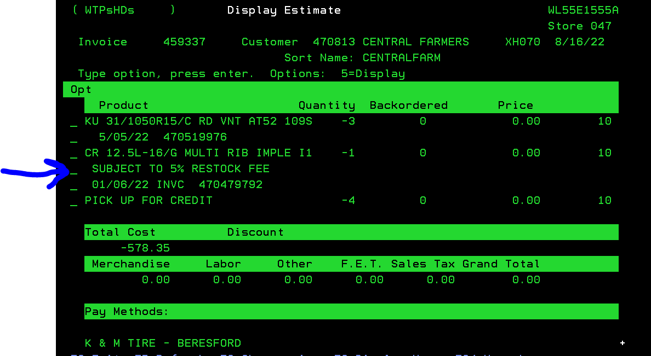

- Login into Maddenco using your WHAMS_ _ login

- 1 Tire dealer System – enter

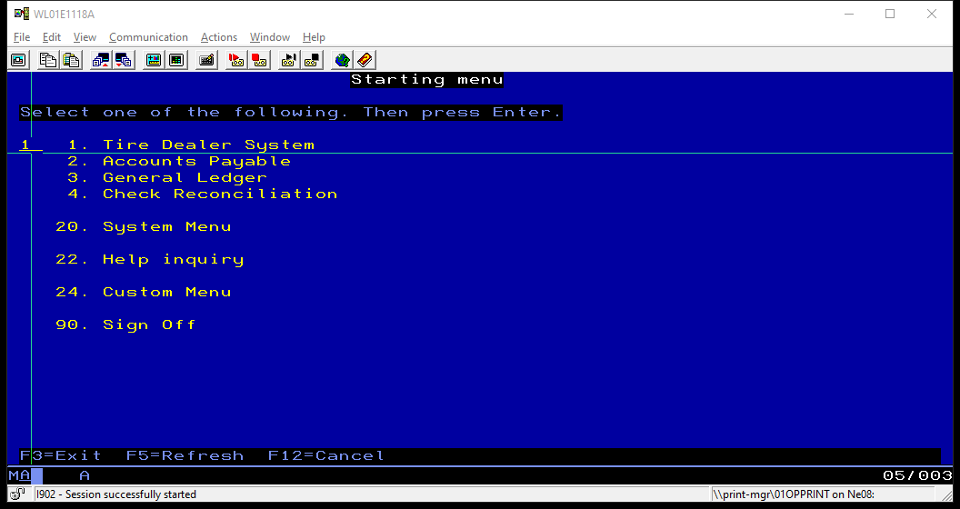

- 7 Warehouse Order Entry – enter
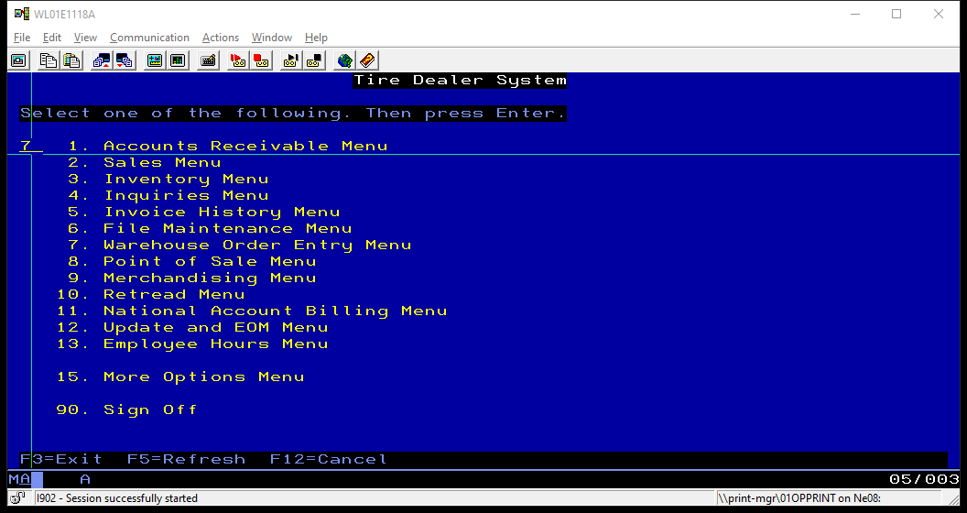

- 1 Order Entry – enter



- Enter location number – tab/enter



- Enter customer number – input the customer number where it says, “show only customer”. The customer number is located on the estimate. Example location being used is loc45

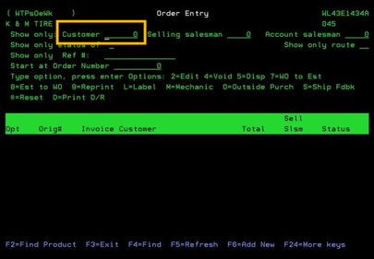

- After inputting customer number (customer 45817 in this case below) and hitting the field exit; it will show all the customers current orders from that day and any estimates (new return credits) that they have in the system that haven’t been credited to their account yet. You will have to hit the F2 key so that it brings up the next step (see next page)

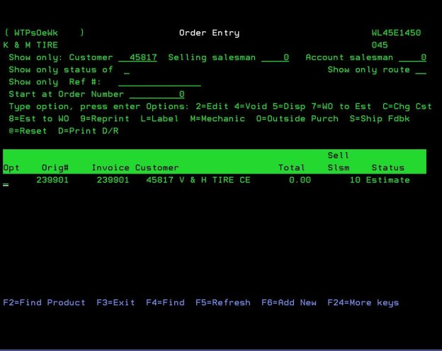

- This is where you can search for tires in Madden Co. When searching using the part number, you always want to use the third option (cursor below). You should be able to find the part number on the Estimate in front of you. Once you have typed it in, press enter.

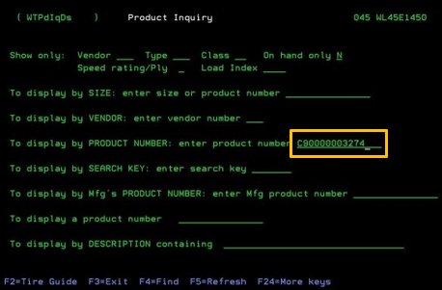

- This will bring up a list of part numbers in the system in alphabetical/numerical order based off of search. Type a “C” on the line next to the product number the customer is returning, and press Enter. “C” stands for customer history. This will display all the dates and quantities that the customer purchased the tire they are returning.

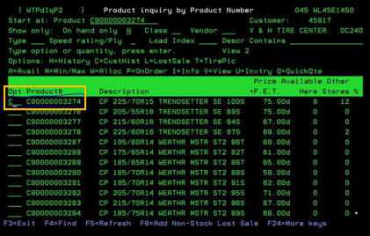

- Find the customer’s invoice where the product was purchased. Type 5 next to the invoice and press Enter. This will display the original invoice. Find the invoice referenced on the estimate. If no history can be found, contact the sales manager or your Customer Service Representative. We might have to return that tire to the customer. There must be purchase history to credit back a customer.

**(Note: Watch for customers with a PR/SSP in their account name. If the tire they are returning was purchased over a year ago, we cannot give them credit, and it will need returned to them. Before returning to customer, confirm with Sales Manager or VP of Purchasing. Also, if a credit for a PR/SSP account has more than one part number being returned and the reference invoices are different for each part, we cannot credit them on the same invoice. Only reference one invoice per credit for PR/SSP accounts only.) **

- There are times you’ll have to check other location’s history for tire purchases. To the right of the product line, you’ll see a line with your location. (Example: below where it says Loc. 45). You might have to check the other locations that direct bill to your customers. Change that number to the other locations you need to check. (Example: Let’s say loc. 43 directly invoices to Loc. 45 customers. You need to type a 43 where the 45 and press enter to search that other location.)

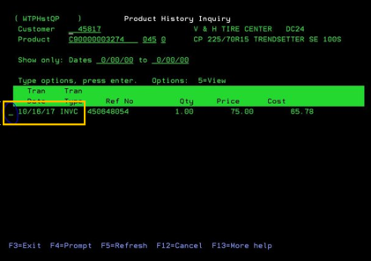

- After viewing the original invoice, locate how much the customer paid for the tires. Make note of the price on your estimate. The price of tires changes quite often, so we must always credit back what they bought them for.

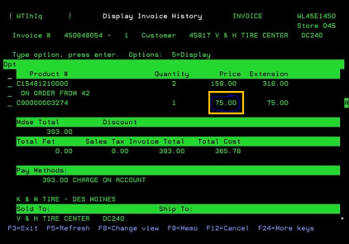

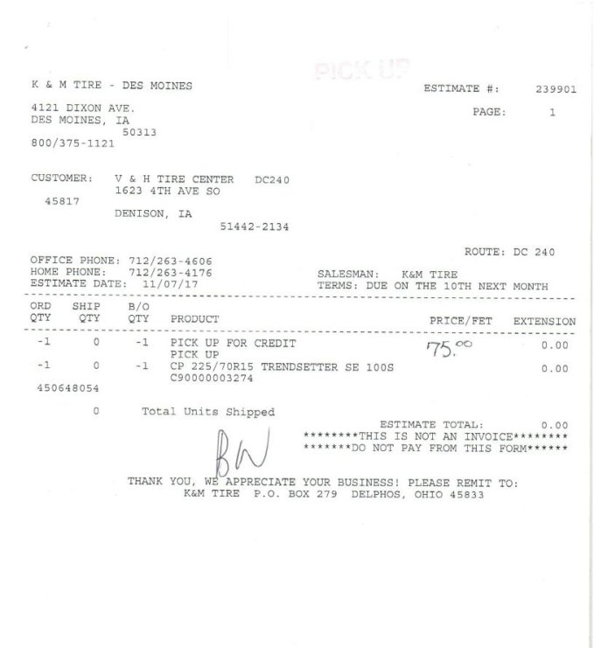

- After determining the pricing, you will return to the Order Entry screen on Step 6. Press F12 until you see Order Entry (F12 x 4). This should get you back to the screen where you entered the customer number in the top left corner (from step 3).

- Next you will turn this estimate (EST# 239901) into an invoice. To do so you are going to put an 8 on the estimate line. See below for example. Then hit enter.
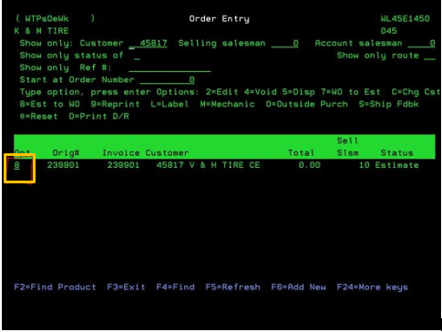

- The screen below will appear. Must make sure “Sell Salesman” line in the top right corner has a 10 (for K&M Tire) or your selling salesman number on it. Press enter.

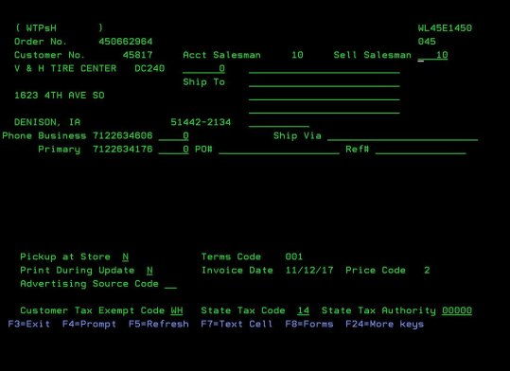

- You will need to enter the price of the product you determined in step 11. Type a 2 on the product line. This will edit the information for that product.

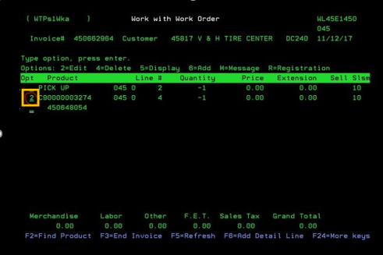

- Double check the quantity. Credits are always a negative quantity. A negative quantity brings product into our inventory and gives the customer a credit. In orange below, you will input the price the customer paid for this tire; see step 9. In this case $75.00. Change the price from 0.00 to 75.00.

** (Note: If the new return credit stated a restocking fee you will have to make sure, they do not receive full credit for that tire being returned. If they paid $75.00 for the tire you will take that price and multiply it by either 0.95 (5% restock fee) or 0.90 (10% restock fee). For example, 75 x 0.95 = 71.25, so you then credit the customer $71.25.)**

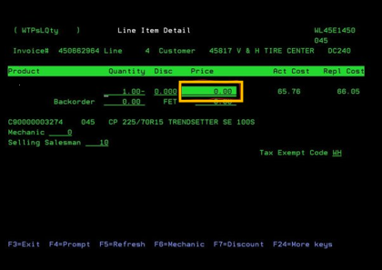.

Note: Notice below that the estimate number has changed to an invoice number.
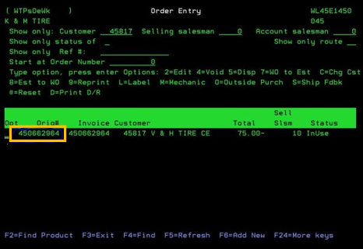
- Type an “S” on the invoice number line (See below). This will ship close the invoice. Press enter, then F3, then enter, then enter again. Status should change from In-use to Invoiced.

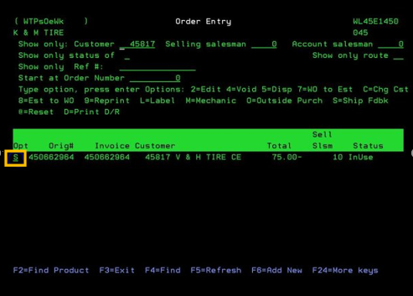

- Close invoice - Y

System Receiving- Non-WISE locations
Warehouses receive vendor loads daily. It is important once the warehouses have the product unloaded and put away, to receive the tires/wheels/parts into Madden Co for our customers to order. Warehouses will email the BOL/Packing list into the WAM once the unloading process has been completed. The following are steps to receive the product into the warehouse’s inventory.
Receiving: The following procedures and notes are to be followed in the process of receiving product into the facility and into the system and K&M Tire Corp. Please use these procedures for all brands.
In Maddenco:
- Type “1” (To enter Tire Dealer System)

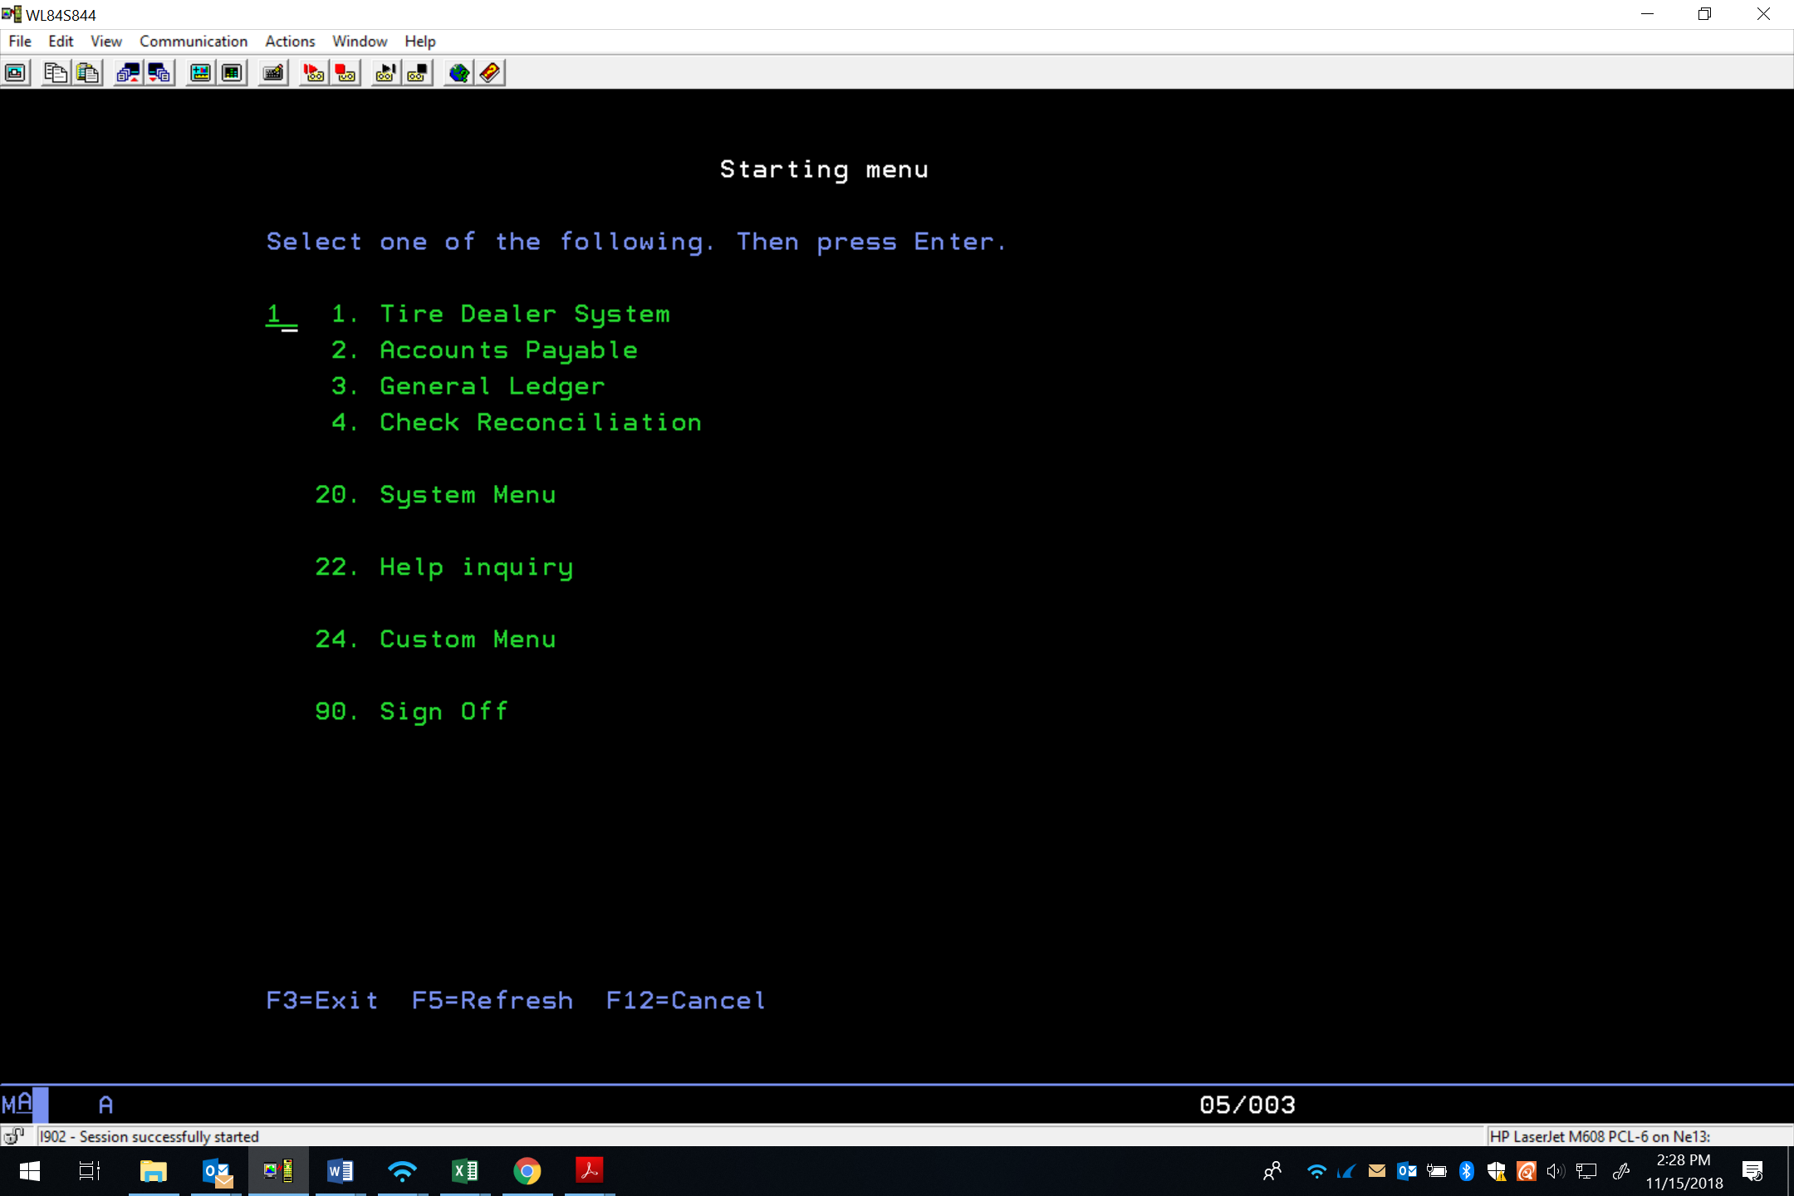

- Type “3” (To enter into Inventory Menu)
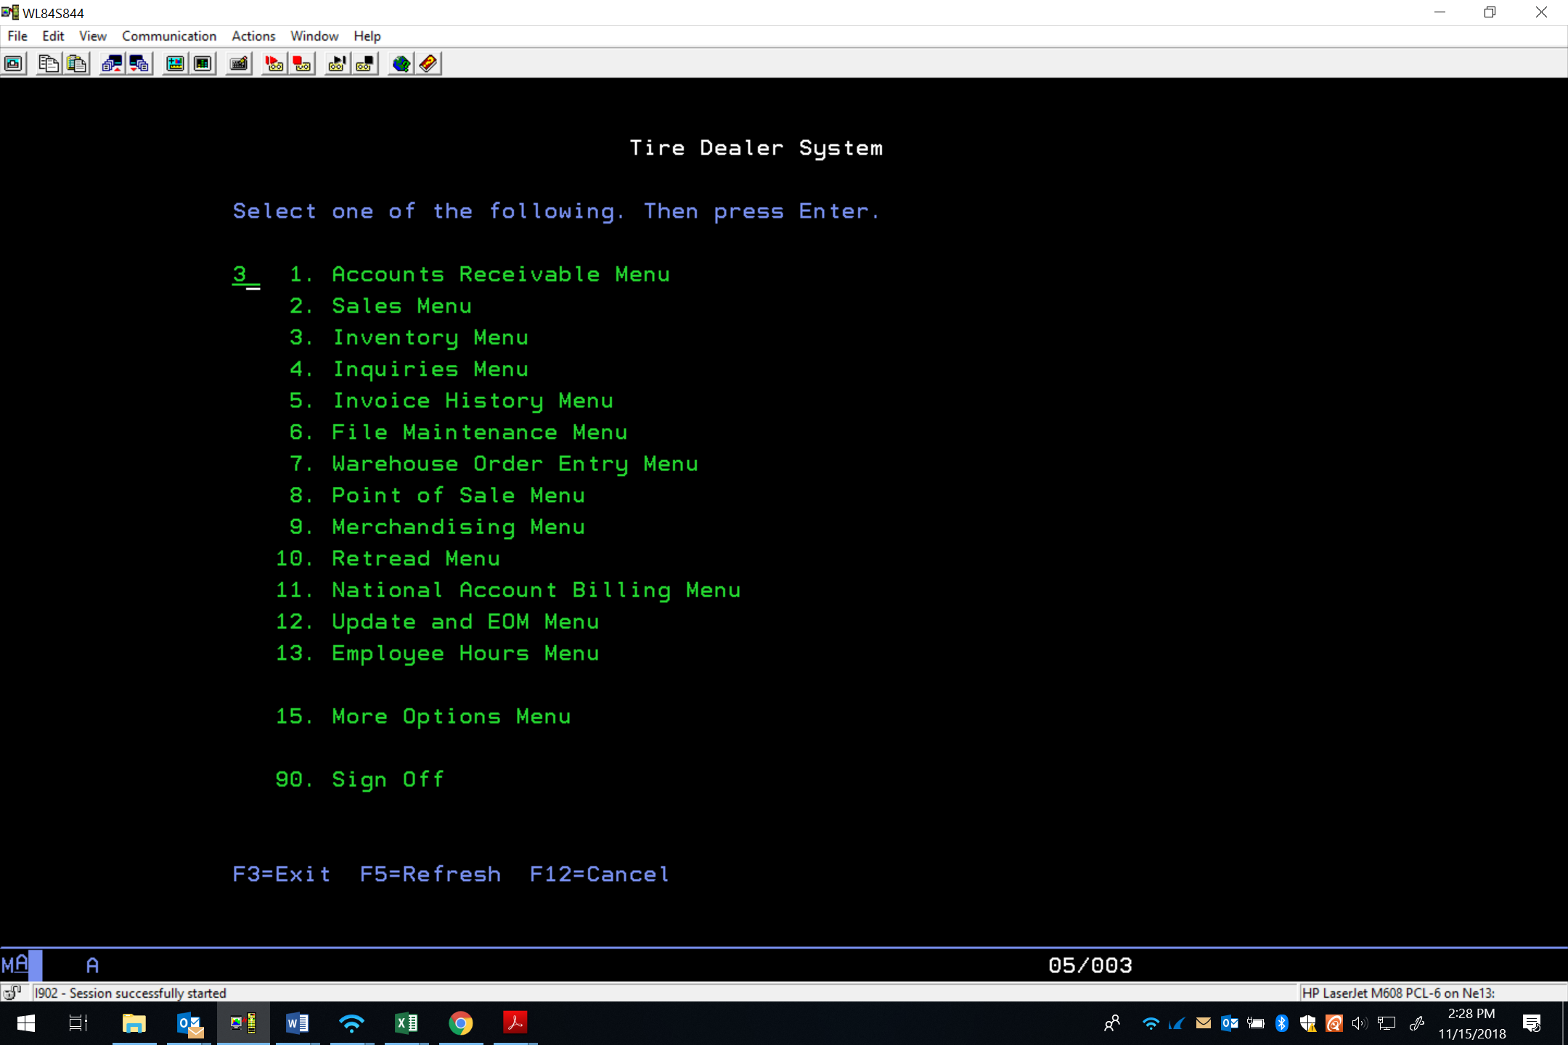

- Type “3” (To enter into Inventory Receivers)
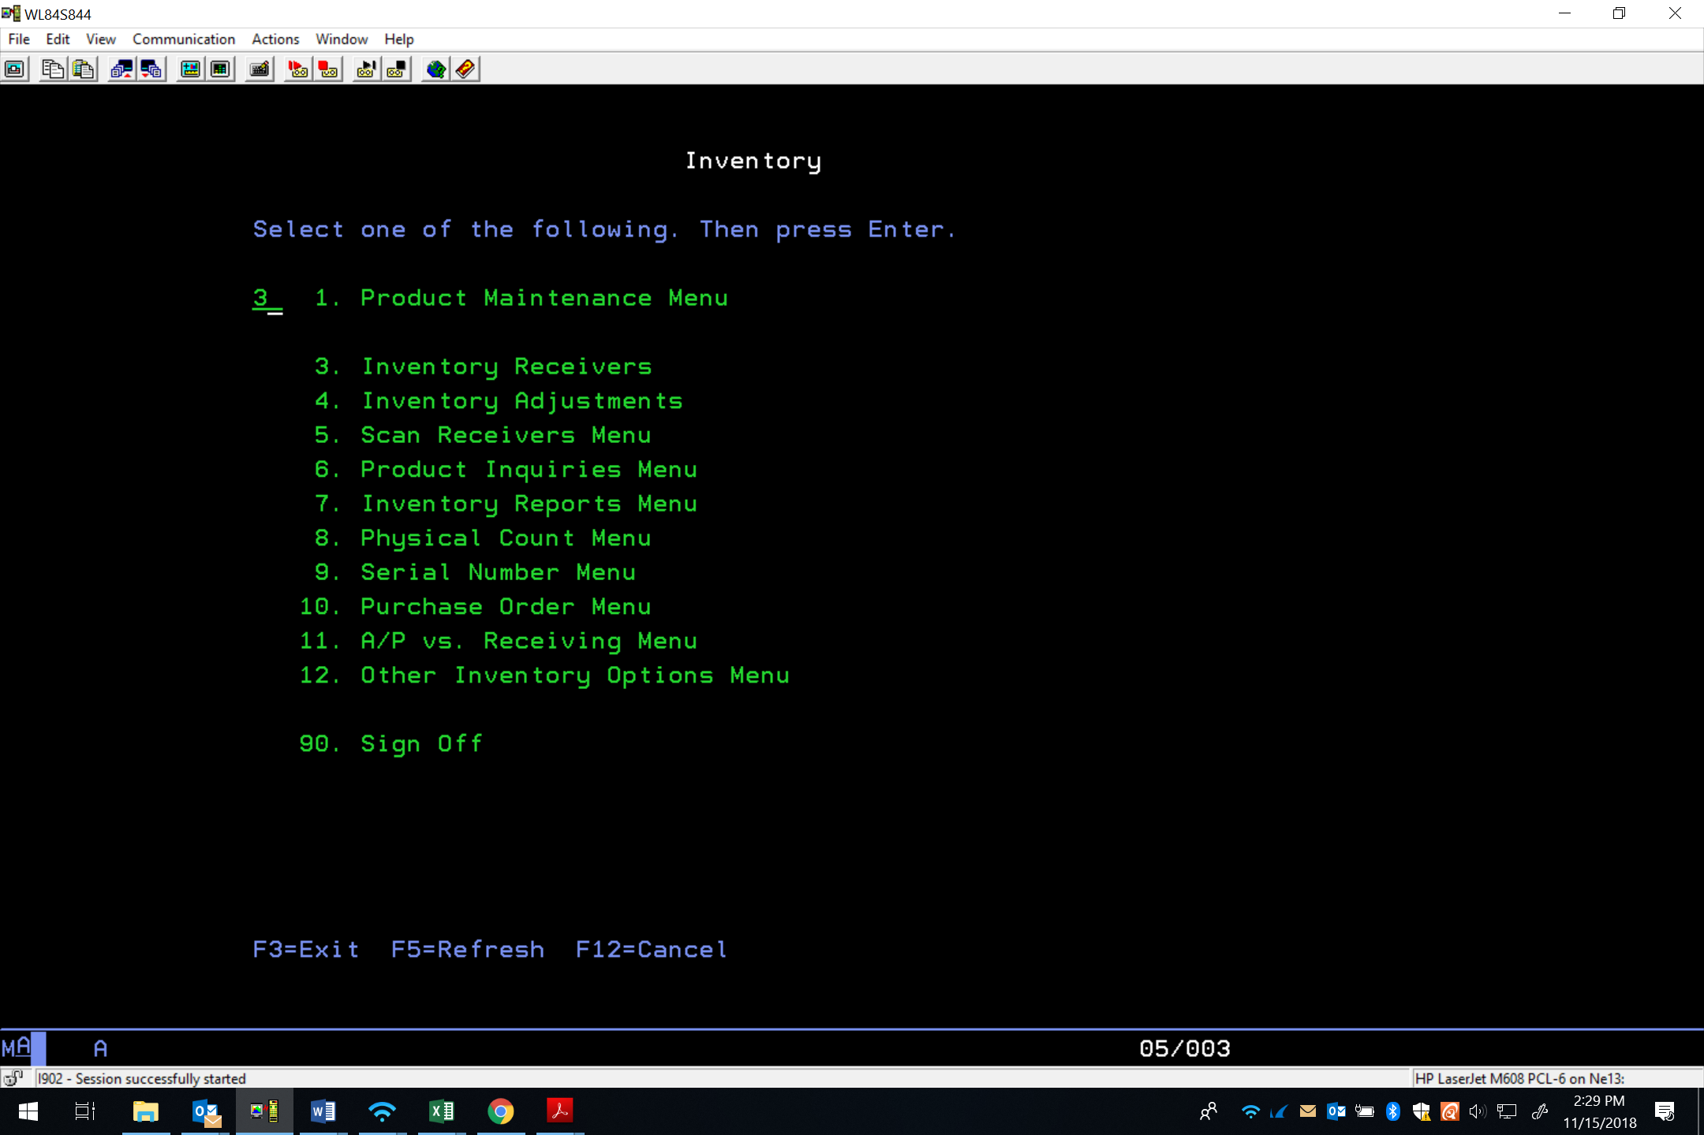

- Enter store #, Field Exit, Enter. This is the warehouse/location you are receiving the product into.
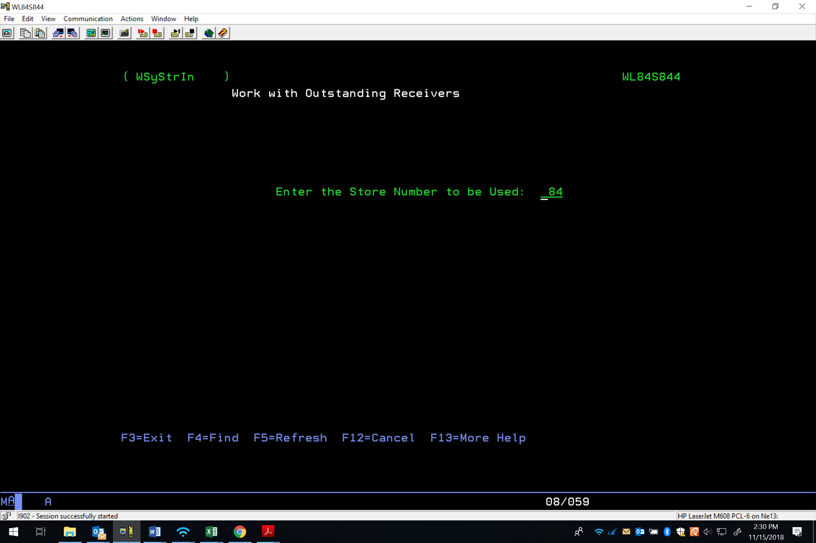

- Press F6 key (create new receiver)
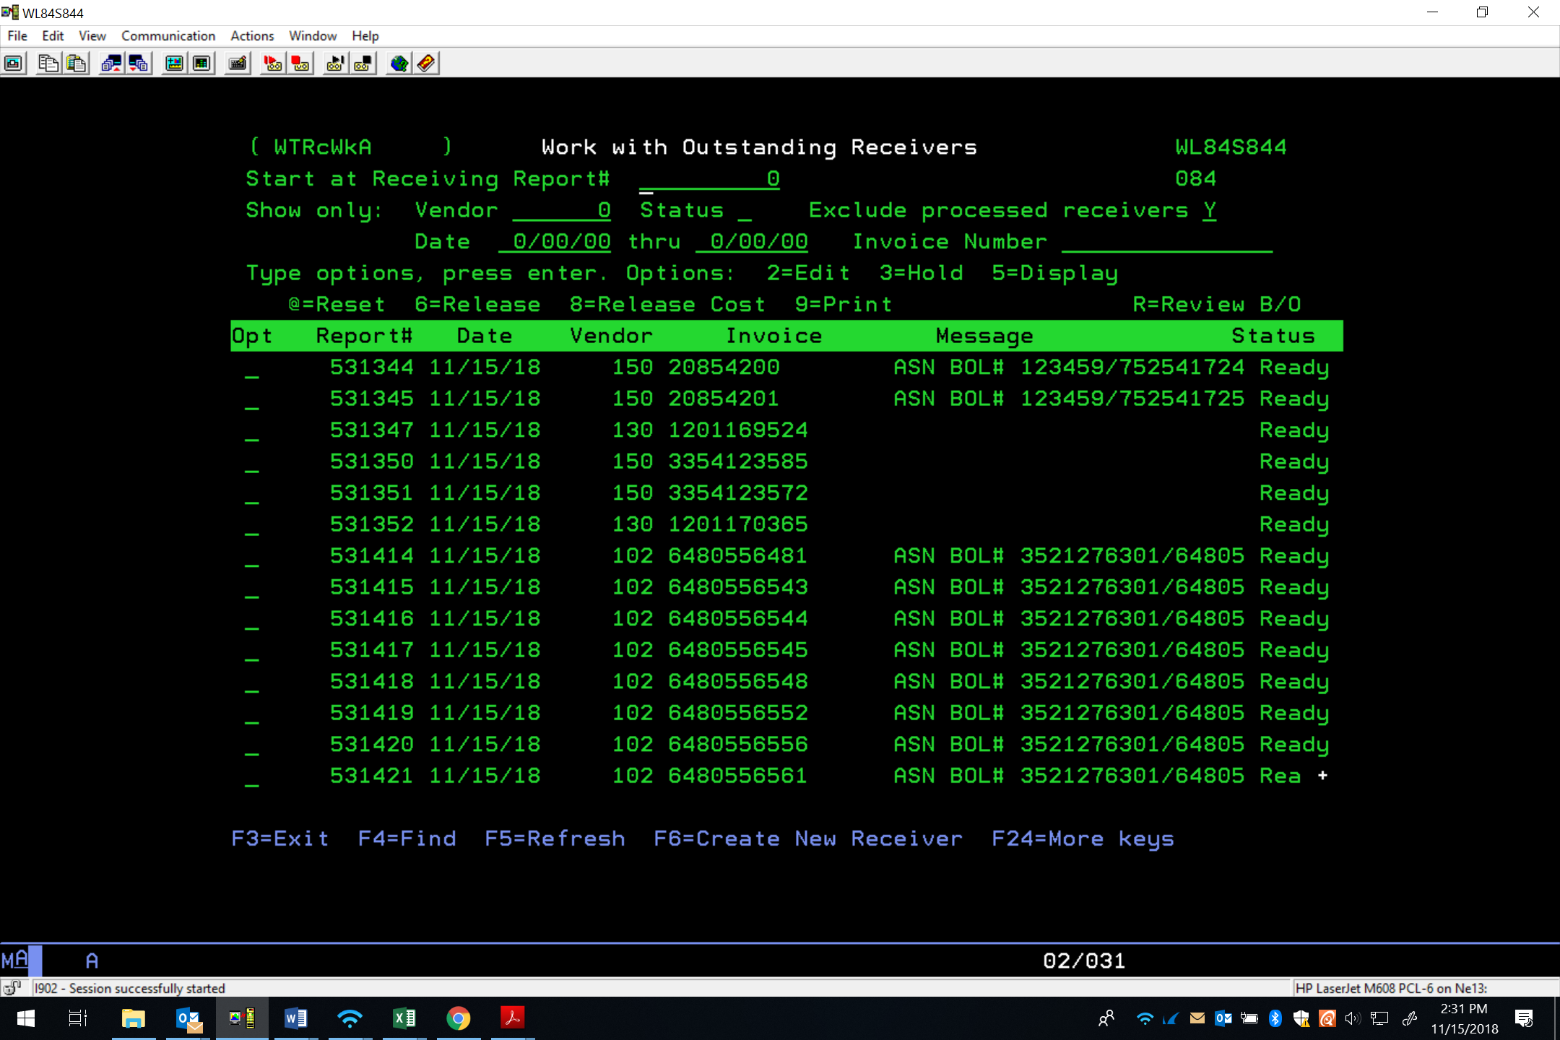

- Press F2 key (Get next report #)

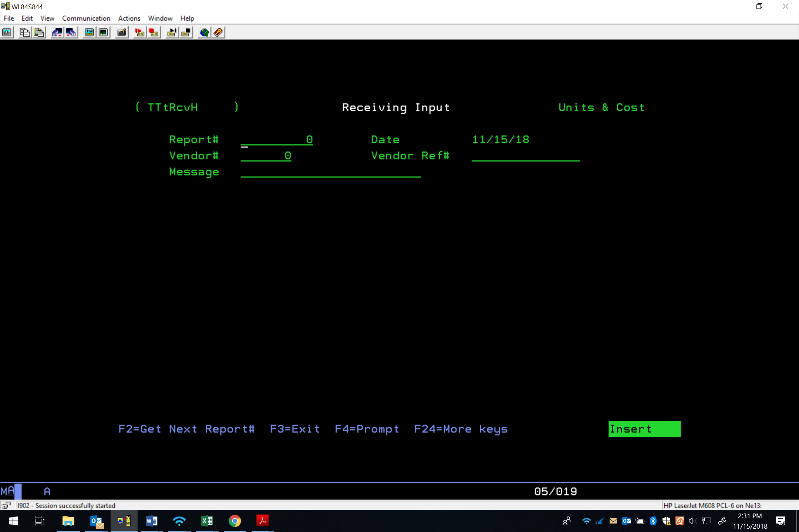
6
6
8
7

- Type in Vendor # or (Can use F4 to search for vendor as to what #) Field Exit (Also see Vendor and Customer # sheet for Vendor #s.) ..\..\..\..\..\Purchasing & Pricing\Shared\Forms & List & Charts\Vendor Shipping Numbers 2-16-2023.xlsx
- Type in Ref # (different by Vendor-see Vendor and Customer # sheet)
- If it is a container, please list the container number on the message line.
- Press Enter
- Press F7 (Copy a PO)
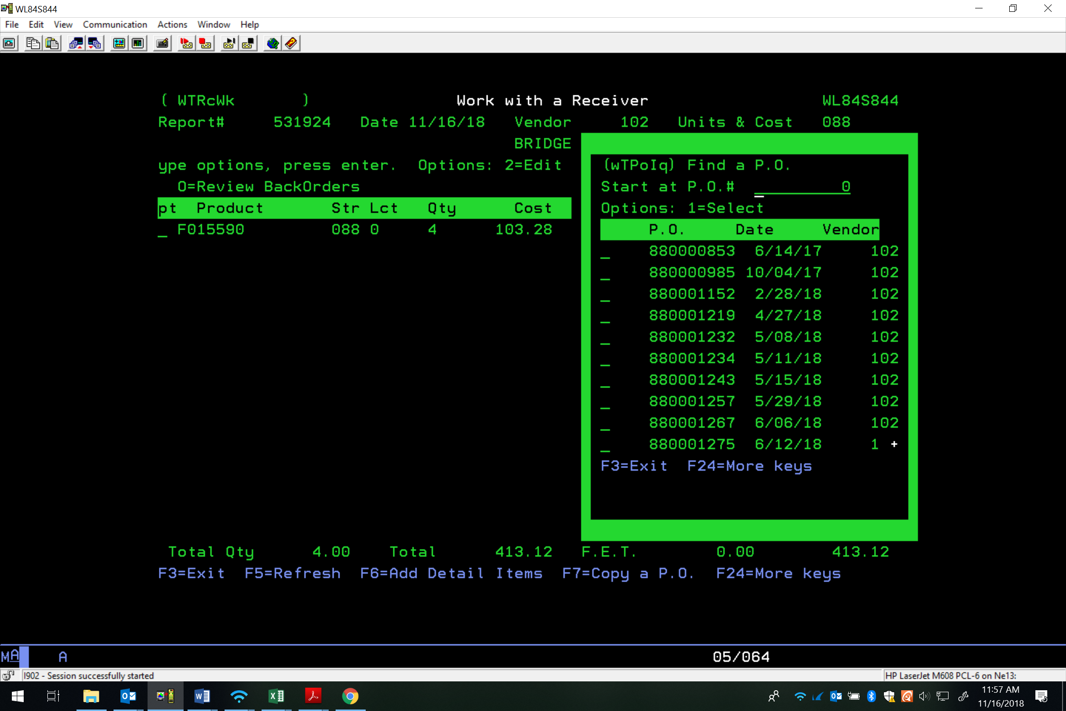
11
10

- Type PO number in, Field Exit, search through open PO numbers by hitting page up or down. When you locate the PO number you want type “1” in front of the PO and hit enter.
- To select product to be entered, place a “1” in front of the products you want to enter, then press Enter. **These will be in alphabetical/numerical order.**

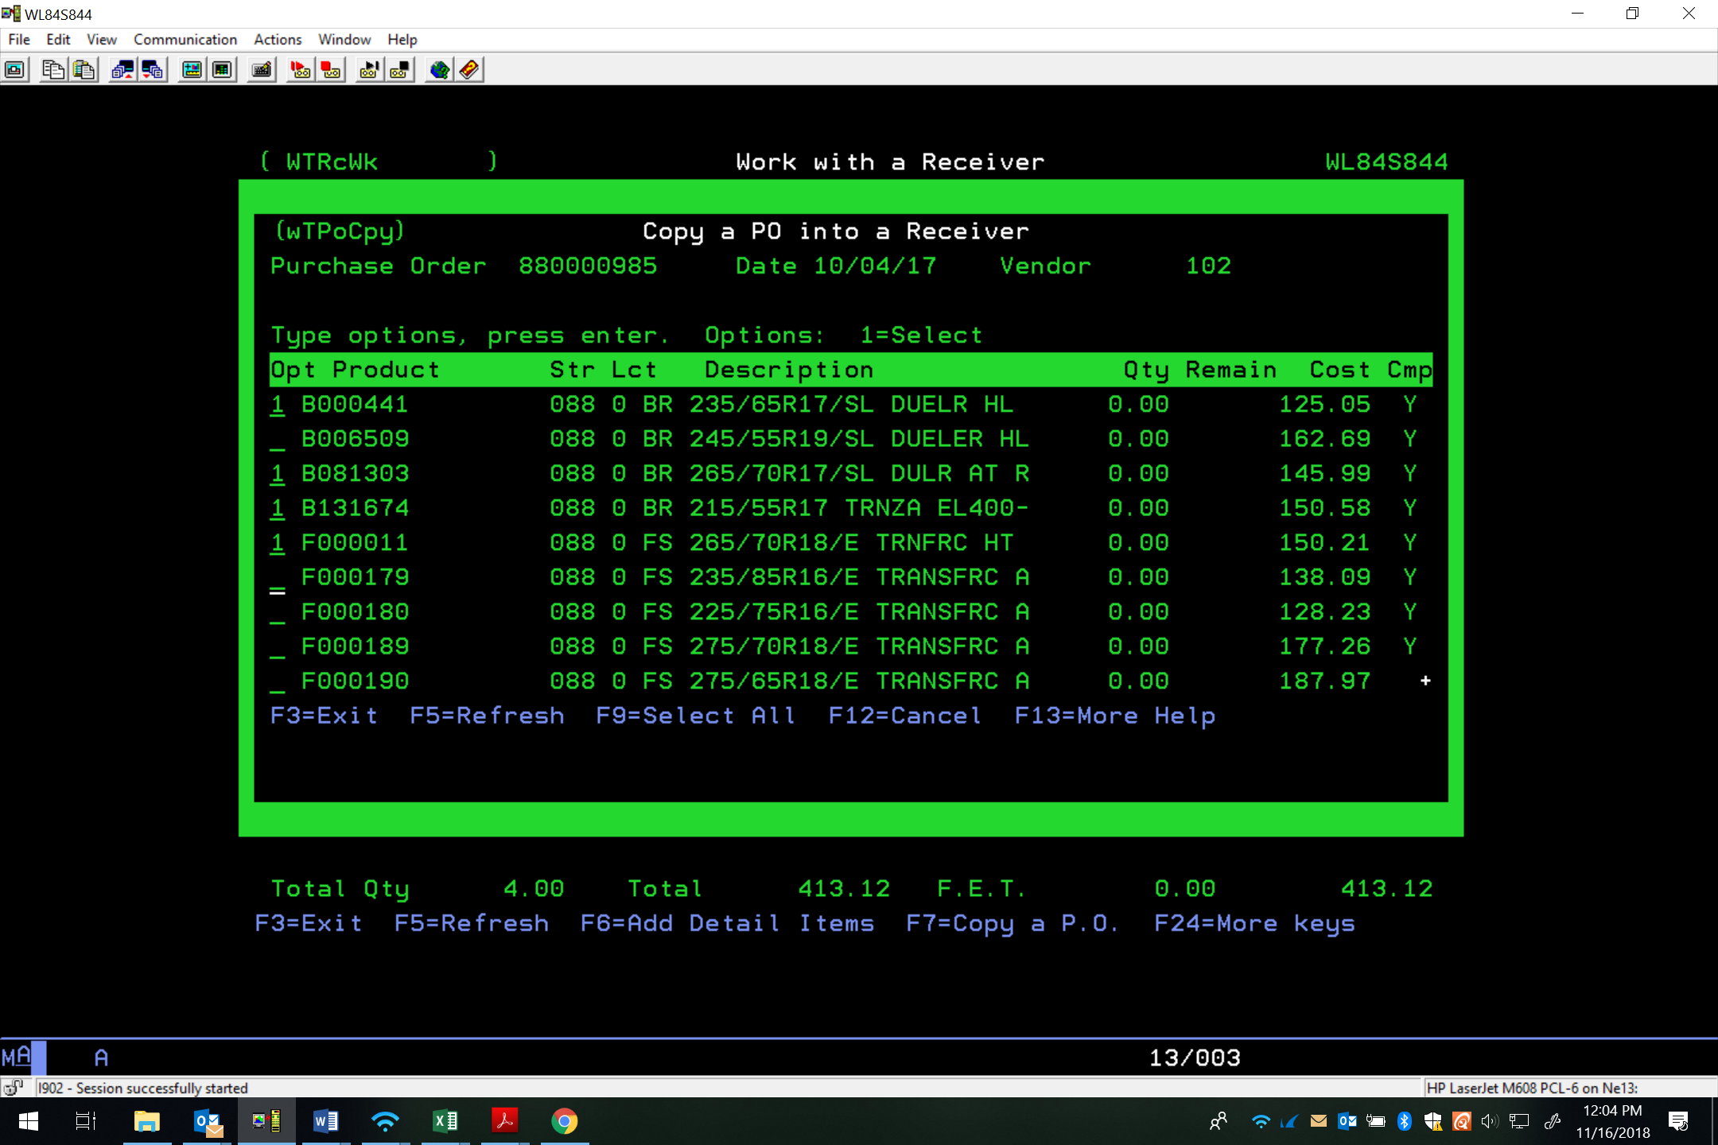

- Verify your quantities, make any necessary edits for partial ships- find the appropriate product(s) and place a 2 in front of them to “edit”, type in qty you did receive from vendor, “Is PO complete?” answer “N”. If you do not click “N” on the last section, the next receiver you will be missing the product and need to call purchasing to add it to the PO. Changing this to an “N” puts the remaining quantity of that product back on the PO to use next time we receive that item. Leaving it a “Y” clears it out of the system which will lead to an issue down the line. This last step is the most important and most common error in receiving.
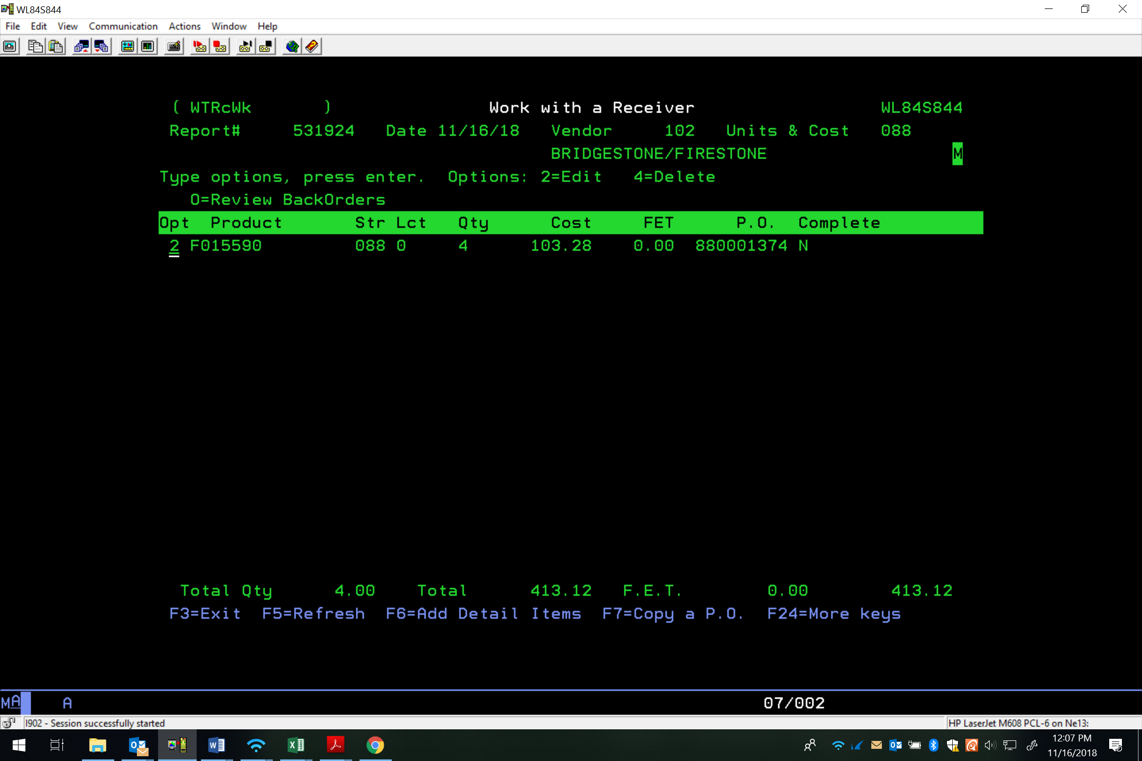

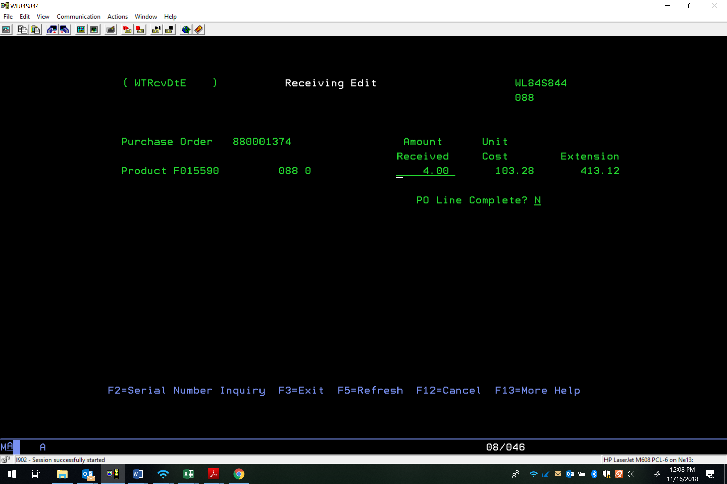
- To end hit “F3” and verify your quantity again—should match total qty- enter that quantity, enter, press Enter.

(Note: It is very important that the quantity matches the BOL. Even if there is an overage or shortage. That will be taken care of afterwards.)

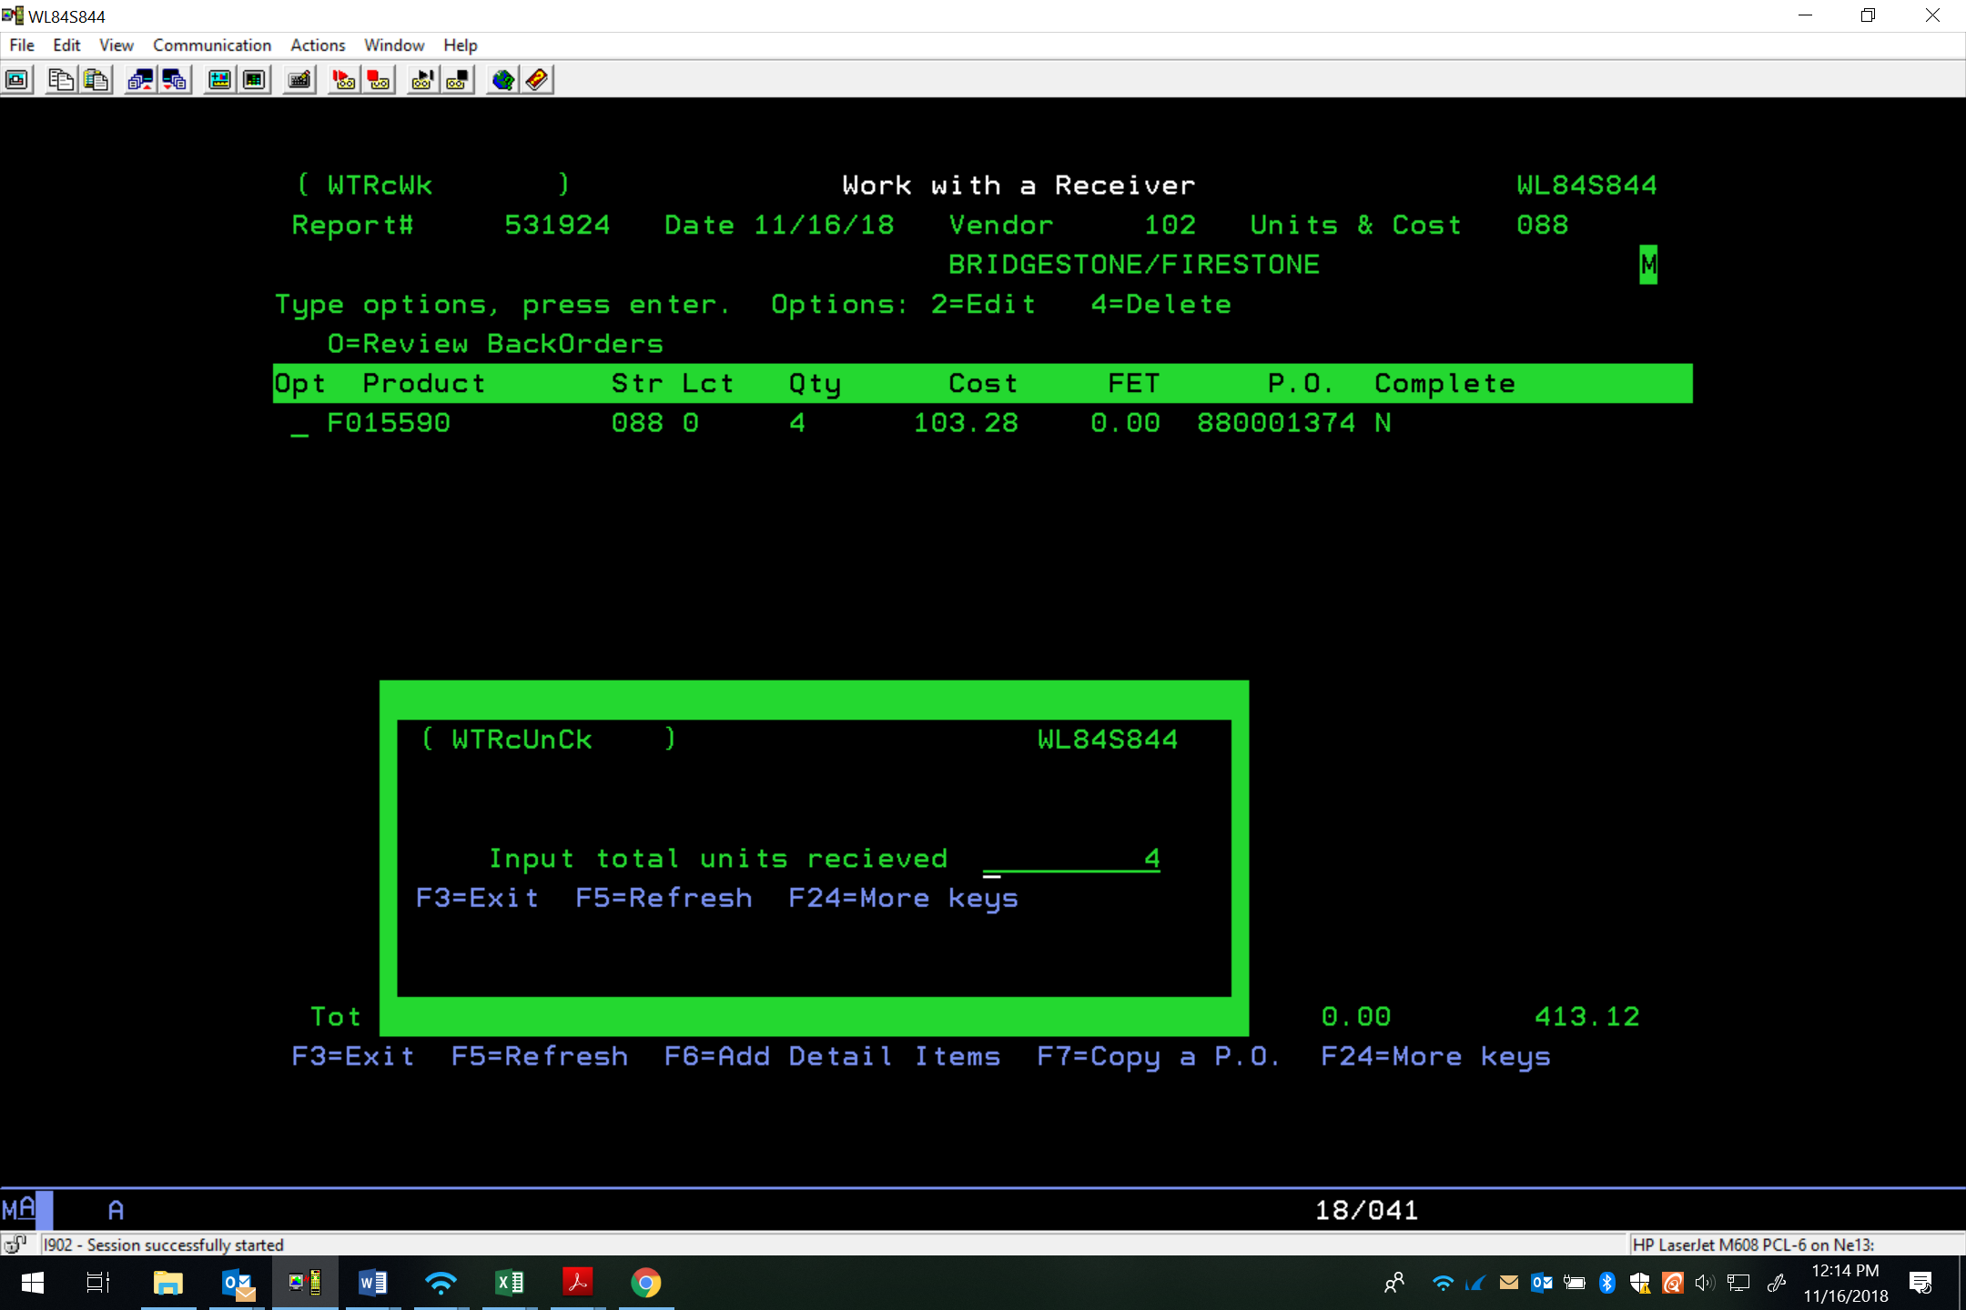

- “Print a copy of the receiver now?” Answer: “N”

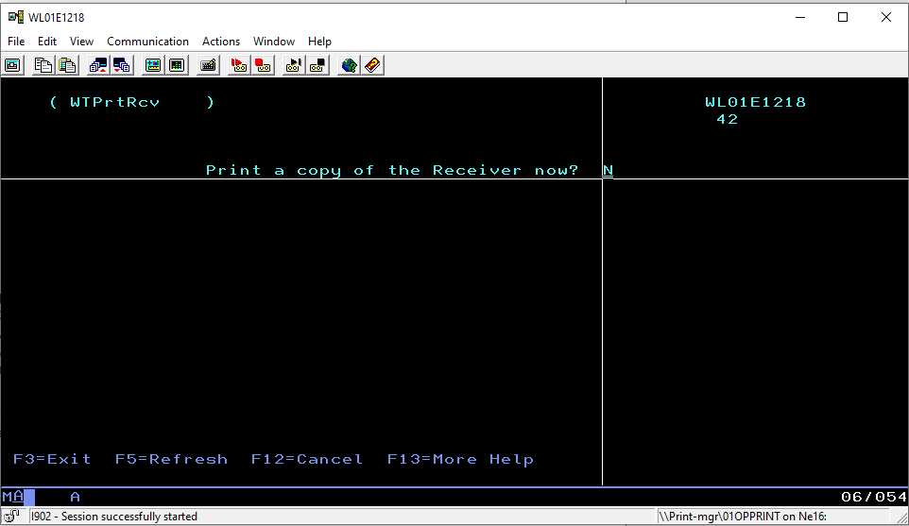

Return Goods Authorization
A RETURN GOODS AUTHORIZATION (RGA) is requested when we receive product that is not stocked by K&M Tire.
- When we have determined that we need to return product to the vendor, the Warehouse Admin Manager (WAM) will request an RGA from Purchasing via email.
- The “To email” needs to include the Warehouse Manager (for tracking from vendor).
- Once we have received the RGA, follow the instructions from the vendor - call tags, return to vendor warehouse, vendor pickup.

  - Warehouse Manager will need to add product to 101086 until picked up to pull from inventory as not to sell if call tags or vendor pickup are instructed for return.
  - If tires are to be returned to vendor warehouse a stock transfer will need to be added to the warehouse returning the tires.
  - Belle Tire returns will need to be transferred to Loc4 and invoiced prior to return as Belle Tire does not do RGAs.
  - An RGA will not be issued if product is non-stock and not set up in Maddenco.

- We should not bill the manufacturer back until they are picked up by UPS, FedEx, vendor or dropped off at the facility. The WAM should then be notified once they have been returned so they can be billed back to vendor.

Building A New Expected Receipt- WISE Locations
(Note: These are important to build ahead of time if possible so that the warehouses are not waiting for receipts to be made. Warehouses on WISE cannot receive new loads without having a receipt to scan them in. Sometimes you’ll have to wait for the warehouses to send the packing list in to make a correct receipt.)
- Log into WISE
- Username: Employee ID
- Password: Last 4 of SSN
- Double click on “Operations”
- Double click on “Inbound”
- Double click on “Expected Receipts”
- Click on “Add”
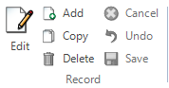
- Enter carrier number:
- BOL number or vendor reference
- Enter sender ID
- This will be the vendor number
- Enter container ID:
- This is a vendor name abbreviation + load quantity (ex. BK 130)
- Click on “Save”

- Click on the Compose tab
- Now you are ready to add your products. Pull out the packing list and start with line 1.
- You will need the K&M part number and PO number.
- Right click on the filter button and select “BY PO”

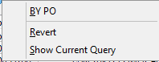

- Enter your PO number in the Source Doc box
- Now look for your product number, and verify the quantity is correct. If the quantity is correct, click on the product line, click on “Add Full,” otherwise enter the quantity you need to add to the receipt in the box above “add partial” button and click on “Add Partial”
- Continue down the packing slip until you’re finished
- Verify quantity matches packing slip
(Note: The quantity on the receipt must match the packing list for it to be scanned in correctly.)
- Add receipt number to the delivery schedule:

- Click View / Edit on corresponding delivery
- Add the receipt number
- Make any other changes needed (Qty, Container number)
- Click update, then close
- This will automatically send an email notification to the warehouse

Importing a Receipt from the Vendor Websites- Wise Locations
(Note: This can save significant time when creating a receipt. You can import an excel document into WISE to build the receipt. You need separate columns, in the order of Part number, quantity, and then the Purchase Order the tires are coming in on. The first steps are the same as above. You will need to create this excel csv file before you can import. See Pulling packing lists from Vendor Websites. Page 43 below.)
- Log into WISE
  - Username: Employee ID
  - Password: Last 4 of SSN
- Double click on “Operations”
- Double click on “Inbound”
- Double click on “Expected Receipts”
- Click on “Add”

- Enter carrier number:
- BOL number or vendor reference
- Enter sender ID
  - This will be the vendor number
- Enter container ID:
  - This is a vendor name abbreviation + load quantity (ex. BK 130)
- Click on “Save”

- Click on the Compose tab

- Under the Compose tab, On the right-hand side, you will see a box with 3 dots in it (see below). Click on that box.
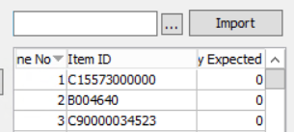
- A box will pop up with from the path F:\Warehouse\Shared\Warehouse Packer. This is where we save all the excel packing lists that are ready to be uploaded in WISE.
- Find the one you created. (Ex. BKT 130.csv. See the step on creating the WISE excel sheet.) Click Open.
- Next click the Import button to the right of the 3 dots box we just used. This will generate that excel file into your receipt.
- Click the refresh button next to the “Total Qty” to update quantity.

- Verify quantity matches packing slip
(Note: The quantity on the receipt must match the packing list in order for it to be scanned in correctly.)
- Add receipt number to the delivery schedule.

Closing A Receipt / Receiving in a WISE Location
(Note: Once an expected receipt has been completed, it needs to be closed in WISE in order for the product to show available for our customers in Madden Co. These steps show how to close the receipt in WISE)
- Log into WISE
  - Username: Employee ID
  - Password: Last 4 of SSN
- Double click on “Operations”
- Double click on “Inbound”
- Double click on “Expected Receipts.”
- Click on the receipt you are wanting to close
  - Click the arrow on links
  - Click on “Expected Receipt Log Report”
  - Click “OK”
- One the receipt is loaded, skip to the last page to verify that full count was received in
- If the quantities match, you can move back to the expected receipts page
**(Note: It is very important that the quantities match or the receipt cannot be closed and must remain open until matched!)
- Make sure the receipt you want to close is selected
**(Note: This is also important because if you close the wrong receipt it could mess up another receiver the warehouse was scanning in!)
- Click on “Edit”

- At the bottom of the page, click on the receipt status drop down menu and change it from “Open” to “Close”

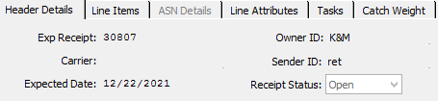

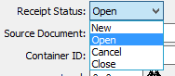

- Once new status has been selected, move your cursor back to the top of the page and click on “Save”

- Once you clicked “Save” the receipt will prompt you to make sure that you want to proceed, click on “Yes”
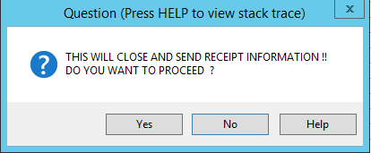
- Once you click on yes, the status of receipt should now say close
- When closed, the load will pop into the receiver’s menu in Madden Co after a minute or so. This will put those tires into inventory.
- If there are any overages/shortages from the load you will now be able to go into Madden Co and claim them as you did back on Sec 1.1.1
- If the load has a shortage, open the “Inventory Entry/Adjustments” page in WISE using the path WISE\Operations\Inventory Entry/Adjustments.

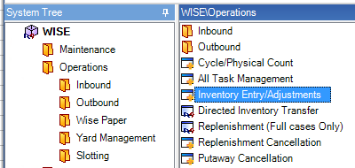

- Enter the product code in the “Item ID” field and hit enter. Click on the line that says T-99.

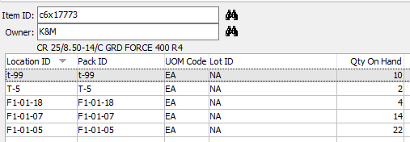

- Click “Edit” on top left of the page and change the “Qty on Hand” to zero on the bottom of the page.

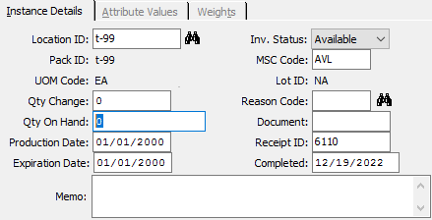

- Click the binoculars next to “Reason Code” and select “WISEONLY” and click OK.

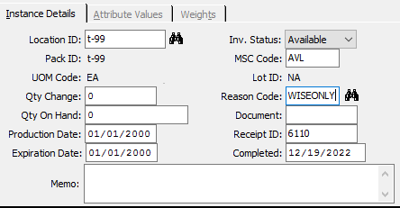

- Click Save on the top of the screen.
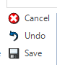
- Click OK on this screen.

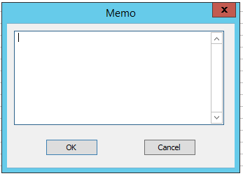

- Click Yes on this screen.

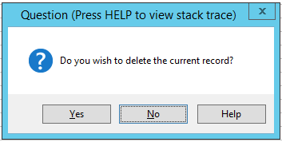

Inventory Variance
(Note: Variance reports are to be run every day, because it helps to synchronize up inventory between Wise and Madden Co. We need to be aware of inventory issues to help correct so we are not risking having shortages.)
- Open the Wise session
  - No need to log into R4 session on remote desktop
- Open File Explorer on the remote desktop
  - Go to This PC>Local Disk C>Temp>ascii>Reports>OUT
- Copy and paste the file to your personal desktop (Not remote session desktop)
- Open File from desktop
- Next, open the F: Drive, Warehouse>Shared.
  - Copy and paste all columns from your daily file to you.
  - Extend the “Rank” box through the last line of your variance by double clicking on the bottom right-hand corner of box.

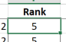

DATA
- Sort and filter excel file by “Rank.”
  - Click on rank box
  - Right click rank box
    - Click on sort
    - Click on option A to Z
- Send the file in an email to the warehouse group and Regional Managers email group.

Pulling packing lists from Vendor Websites

- When finished building the excel document from the vendor website (instructions below), refer to “Building A New Expected Receipt – WISE Locations” on page 34 and follow the steps to finish the receipt in WISE.

Bridgestone/Firestone

- Sign into TreadNet: https://treadnet.bridgestoneamericas.com/b2bstorefront/b2b/en/USD/login

- Click “Shipments” on left side.
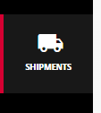

- Click “Advanced Filters” to get the drop down menu and then select “Shipment #”.
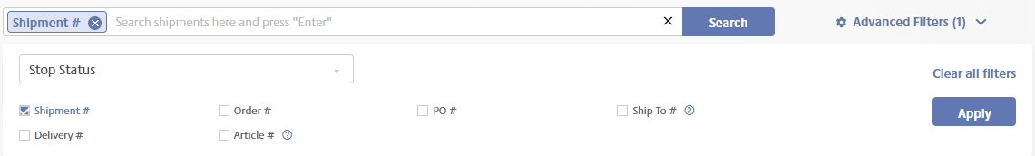

- Enter the Shipment number from the packer and click “Search.”
- Click on the Shipment # to open.
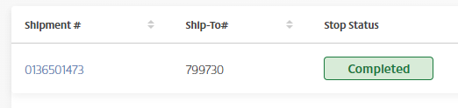

- On the drop down menu at the bottom, click “Show All”.
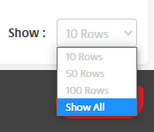

- Highlight all the info, copy, and paste into an Excel sheet using the “Match Destination Formatting” option.
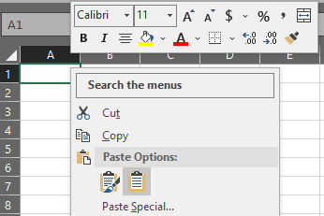

- Edit the Excel sheet so the part number is in Column A, quantity in Column B and PO in Column C.
- Use the “BR/FS VLOOKUP” file in the “F: Drive> folder to get the actual part number.

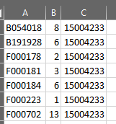

- Save file in the “F: Drive>Warehouse>Shared>Warehouse Packer” folder and change the “Save as type” to “CSV (Comma delimited)”.

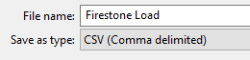

Goodyear
1. Sign into Tire-HQ: https://www.tire-hq.com/
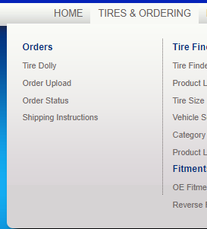
2. Hover over “Tires & Ordering” and click on “Order Status”.

3. Get the Delivery number from the packer.
- Enter it in the “Delivery Note” field and click “Find.”

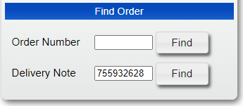
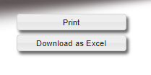
- Click “Download as Excel”.
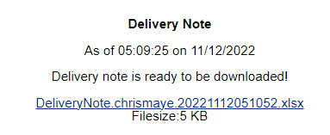
- Click the link to open the Excel file.
- Highlight all the information.
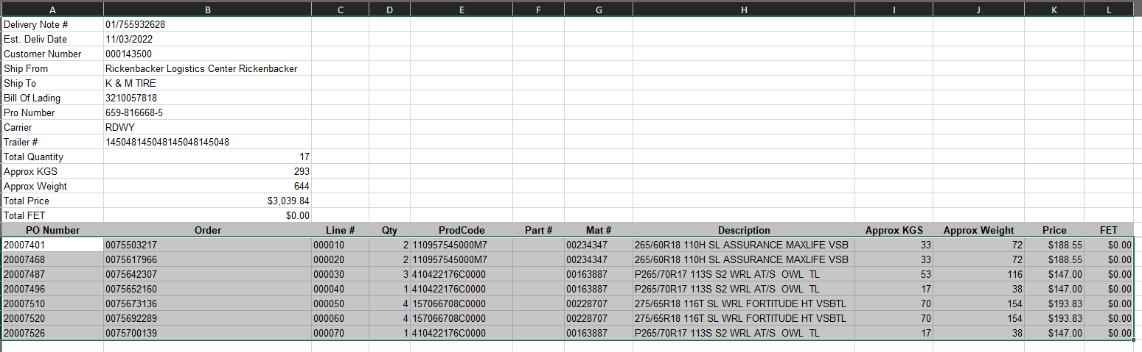

- Copy and paste into an Excel sheet using the “Match Destination Formatting” option.

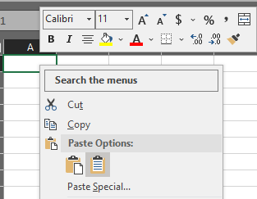

- Edit the Excel sheet so the part number is in Column A, quantity in Column B and PO in Column C.
- Use “Text to Columns” to get the product code down to 9 digits then use the “Goodyear VLOOKUP” in the “F: Drive>Warehouse> folder to get the actual part number.

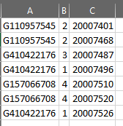

- Save file in the “F: Drive>Warehouse>Shared>Warehouse Packer” folder and change the “Save as type” to “CSV (Comma delimited).”

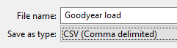

Falken

1. Sign into Falken: https://www.falkenspeedshop.com/portal/login.jsp

2. Find your load and click the “three dots” button.
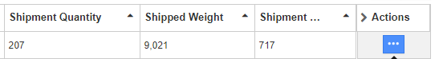

3. Click the “Export to Excel” button then click the “All Lines” button to open to Excel file.
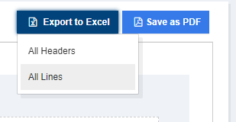
4. Edit the Excel sheet so the part number is in Column A, quantity in Column B and PO in Column C.
5. Use the “CONCATENATE” formula to add the “F” in front of the part number.

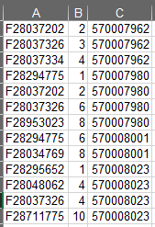

6. Save file in the “F: Drive>Warehouse>Shared>Warehouse Packer” folder and change the “Save as type” to “CSV (Comma delimited)”.
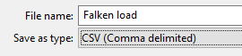

Hankook

      - Sign into Hankook: http://eorder.hankooktire.com/front
      - Hover over “Status” and click “Order Status & Returns.”
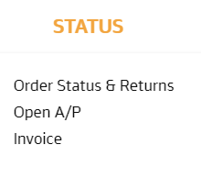
      - Get the “Shipment number” from the Hankook packer.
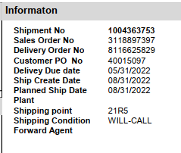

      - Change the Order Date to go back 6 months prior and enter the Shipment Number in the “Shipment No.” field. Click “Search.”

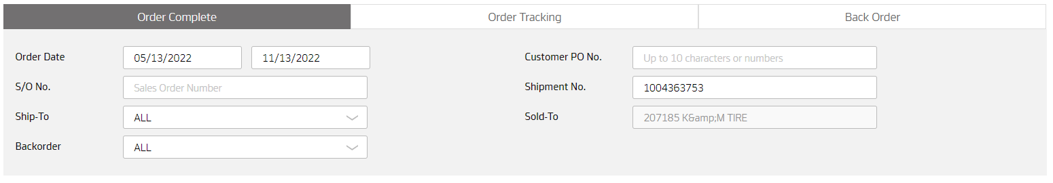

      - Click the “Excel Download” button to open the Excel sheet.
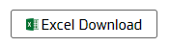

      - Save file in the “F: Drive>Warehouse>Shared>Warehouse Packer” folder and change the “Save as type” to “CSV (Comma delimited)”.

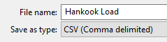

Appendix A: Revision History Tracking
The following table records information regarding changes made to the Operations Binder.

Table 6 - Revision History Tracking
Version Number | Date | Author/Owner | Description of Change
 | 1/19/23 | Kayla Perrine
 | 1/20/23 | Kayla Perrine
 | 1/24/23 | Kayla Perrine
 | 1/31/23 | Donna Burgei
 | 2/16/23 | Kayla Perrine | Made small changes requested by Cheryl
 | 2/20/2023 | Shaina Johnson | Added 6.3 RGA
 | 6-9-23 | Kayla Perrine | Added section 7 Scrap Tire Billing
 | 4/30/2024 | Shaina Johnson | Replace Section 8: Building a New Expected Receipt
 | 11/17/2025 | Angie Prichard | Updates throughout, Removed Section 6.2 ASN Receiving-NON-WISE LOCATION  Removed Section 7 Scrap Tire Billing  Removed Section 9.1.36 & 37 Closing A Receipt / Receiving in a WISE Location
 | 12/4/2025 | Angie Prichard | Removed all highlighted areas marked in the approved SOP

